**Requirements**

What is the app about? Elaborate in detail. How will this app be useful?

“Myde Abaya” app is a platform targeting women where they can design abayas instead off shopping and choosing one of the abayas that are pre-made from shops.

This app is going to give users good advantage to design their own abaya themselves, avoid sheeting on fabrics, and unprofessional tailors.

**Abaya design app - How does the app work?**

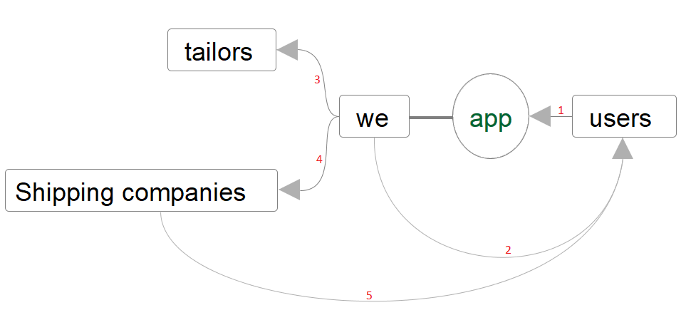

below are the steps in details explaining this picture:

1. The user will:
2. go to the app and design an abaya,
3. review their design
4. make an order and pay, (sing up and complete profile at this stage is mandatory)
5. after payment the user will get receipt.
6. We need to contact all users who sing up from outside the app externally (like emails and WhatsApp ..etc.) because we need to make sure there is no mistakes on the design or misunderstanding from the user.
7. We take the design to the tailors to sewing the abaya.
8. When the abaya is done, we take it and wrap it and send it to the user via one of the shipping companies.

**Explain the entire process from user’s point of view (e.g. what happens after user installs the app).**

After install the app, the user can sing up or skip until payment stage. When the user decided to sing up, the user should give (user name, email, mobile number,) only, then she will receive OTP to verify his account. *But at payment stage she should give additional info to complete her profile (full name, gender, age, address).*

After the user singing up or skip, she will go to the first page:

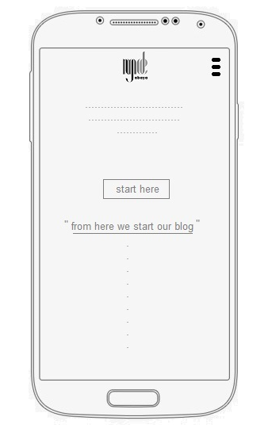

From the first page the user can go to the Design Page or browse the blog and scroll down to see more of our blog or go the menu.

At the Design Page, the user will do (designing abaya) and will be able to access his control panel any time – if she already sing up- to see for example her old designs or complete another one, or complete her profile.

When the user finished her design, she will press (finish my design) and go to another page we call it Review Page to see all details of his abaya.

At Review Page, the use can go back to the Design Page or go to the Payment Page.

After finished the payment, the user will go to Receipt Page. a copy of that receipt will be sent to his email address automatically.

**Explain the management of app from admin’s point of view, such as levels of controls and features required for the app.**

In general, I don’t have any experience of managing apps, so I need anything helpful like metrics and reports, plus features that allow main admins (level one) to:

1. edit items library and its details, (add, delete, change)
2. edit the blog
3. edit user’s info (any info) and that info can be export as excel file.

This table can be filtered (a-z, 0-9, date)

|  |  |  |  |  |  |  |  |  |  |
| --- | --- | --- | --- | --- | --- | --- | --- | --- | --- |
| name | Membership No. | Mob. | Email | Gender | Age | city | pay | No. of orders | Extra details |
|  |  |  |  |  |  |  | (Yes or no)  (Date & time) |  | We can write anything here. |

We have two levels of control

1. Level one: three admin’s full control,
2. Leve two: five people can only access user’s info without edit any info except last box in red (extra details).

**What are all the features offered by the app?**

1. The First mobile application that offers abaya design
2. User can Customize abaya design by adding details from the library/items.
3. Combines among more than 200 sketches available to create best design.
4. Finalize abaya design with zippers, buttons, belts and pockets fabrics and more.

**Describe the process and functions of each of the process/features (such as Size, Model, Fabric, Divisions, Neckline etc.). Please put a heading to discuss each item in detail.**

* **What happens in the Model Screen:**
* **What happens in the Fabric Screen:**

Design Page:

1. when the user goes to this page she will have an abaya sketch as sample/pre-designed (we will choose that sample later) and from that sample, the user can change/design that sample as she wish!
2. The items will appear at the right (because of Arabic language), and the items library box at the bottom, except some items will have its library in pop up window.
3. When user select any item, the library of that Item will appear on the items library box to select/choose one of the details.

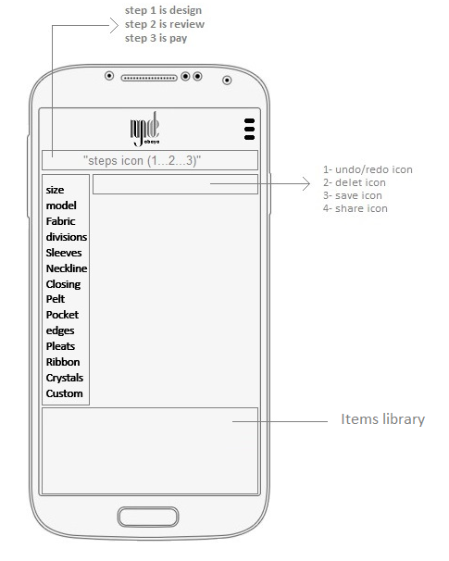

1. Size: (required), Abaya size starts from (30 to 62) tall, and (XS – S – M – L – XL – XXL) width. When the user chooses the size, nothing will change on the abaya sketch. This only appear on the review page.
2. Model: (required), we have 5 models and the user should choose one.

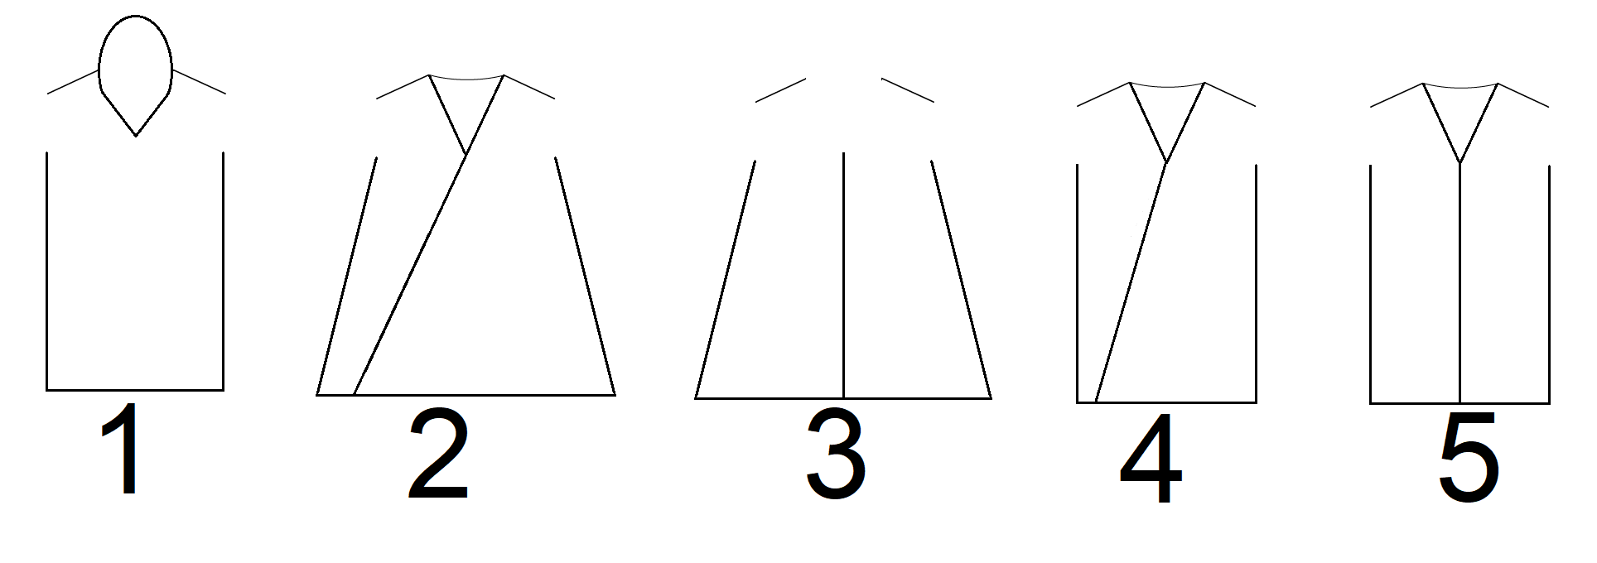

1. Fabric: (required) fabrics are not going to be sketches, it is just a pop up window with high resolution picture, the user should select one of the fabric pictures.
2. Divisions: (required), this item is going to be the largest item, we have about 50+ sketches for divisions appears on the items library and the user should choose one of them, here are some examples:

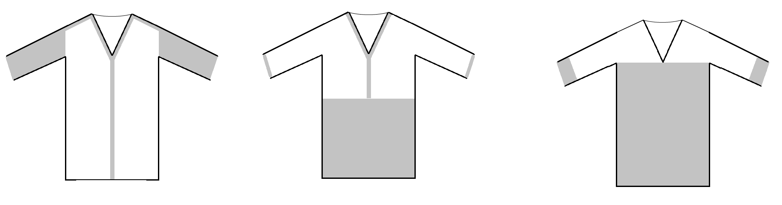

1. Sleeves: (required), we have about 20 different sleeves details.
2. Neckline: (required), we have about 20 different neckline details.
3. Closing: (required), we have about 20 different closing details.
4. Pelts: (optional), we have about 4 different pelts details.
5. Pocket: (optional), we have about 10 different pelts details.
6. Edges: (optional), this item should be a pop up window, so the user shall choose in order:
7. Choose where

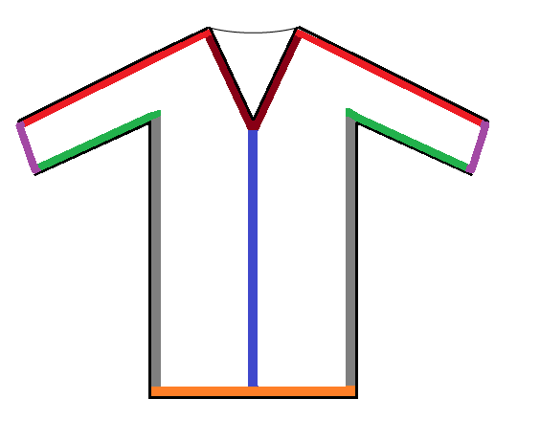

1. Choose what

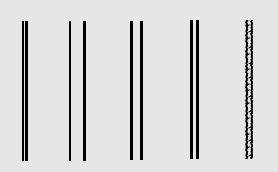

1. Pleats: (optional) the user should choose in order:
2. One of 3 different types of pleats sketches (big , medium, small)
3. When the user choose the pleat, he can put it in anywhere on the abaya, and they all should be sizable. So, we need to use sizable tool (maybe) like this:

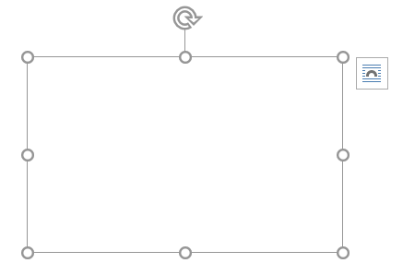

The user can control the pleats horizontally, vertically and rotate it.

1. Ribbon: (optional) the user shall choose in order:
2. The type of fabric: (same abaya fabric, lace, satin or velvet).
3. Then the user will control the ribbon like pleats (sizable tool) because ribbon could be anywhere on abaya.
4. Crystals: (optional) this item is pop up window, so the user will choose in order:
5. Where to add crystals on abaya (fixed places in sketches)
6. What kind of crystals (high resolution pictures) we have about 10 different types of crystals.
7. Custom: (optional) the user can write some additional details and can upload pictures. What the user write or upload should be seen in the review page.

**Do you have all the artwork for sketches? What kind of artwork do you need for the app? Show some examples to support your answers.**

No, I do not have the sketches yet, but I need them like in the (fashion design app <http://www.fashiondesignapp.com/> ).

**How frequently would you like to update the app?**

Two to four times every year. We are expecting 100,000+ users!

end